COM535 Cyber Security Lab

Instructions

- Visit https://www.hacksplaining.com/lessons

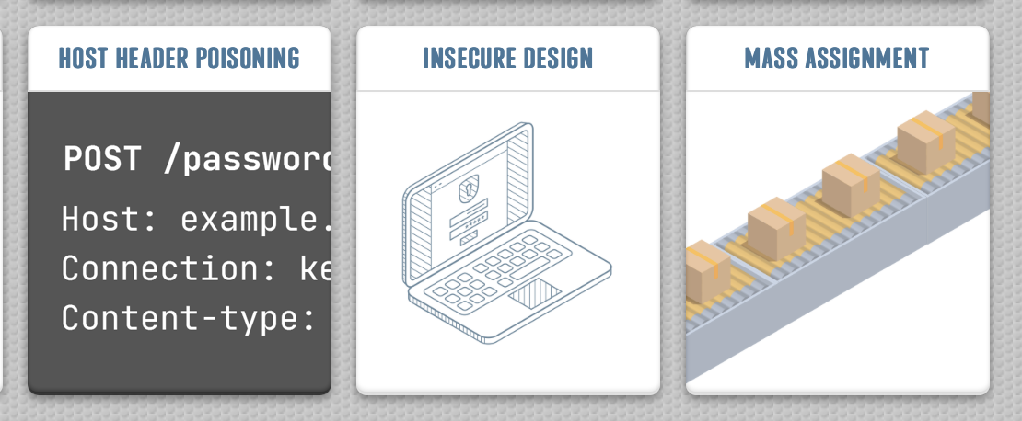

- Complete the three vulnerability lessons which are Host Header Poisoning, Insecure Design and Mass Assignment.

Critical vulnerabilities

- Complete Confluence CVE-2023-22515
https://tryhackme.com/room/confluence202322515

Help Video: https://youtu.be/qpXqtcbR7go

- Complete Looney Tunables
https://tryhackme.com/room/looneytunes

Help Video: https://www.youtube.com/watch?v=lv4e742FR_8

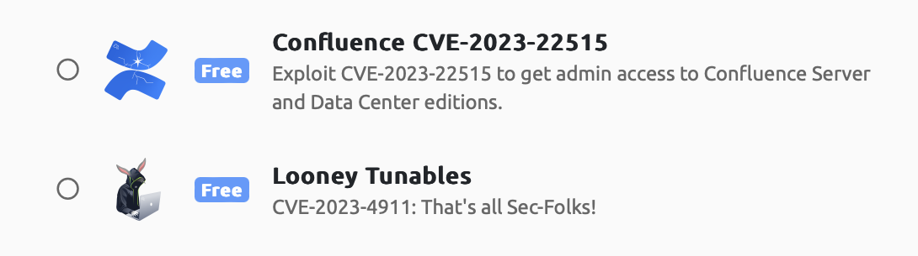

Vulnerability Research

- Complete Vulnerabilities 101 https://tryhackme.com/jr/vulnerabilities101

Help video: https://youtu.be/tt3vFjVrP80

